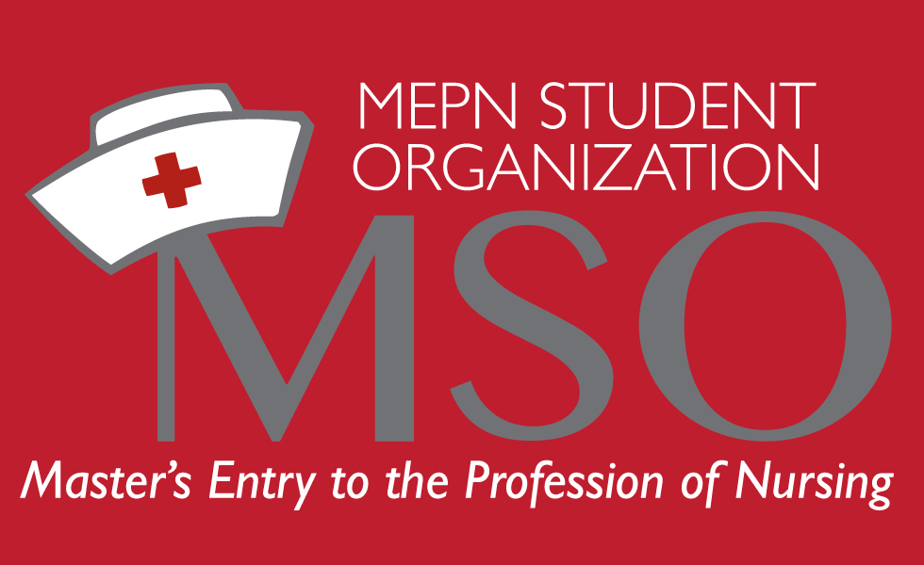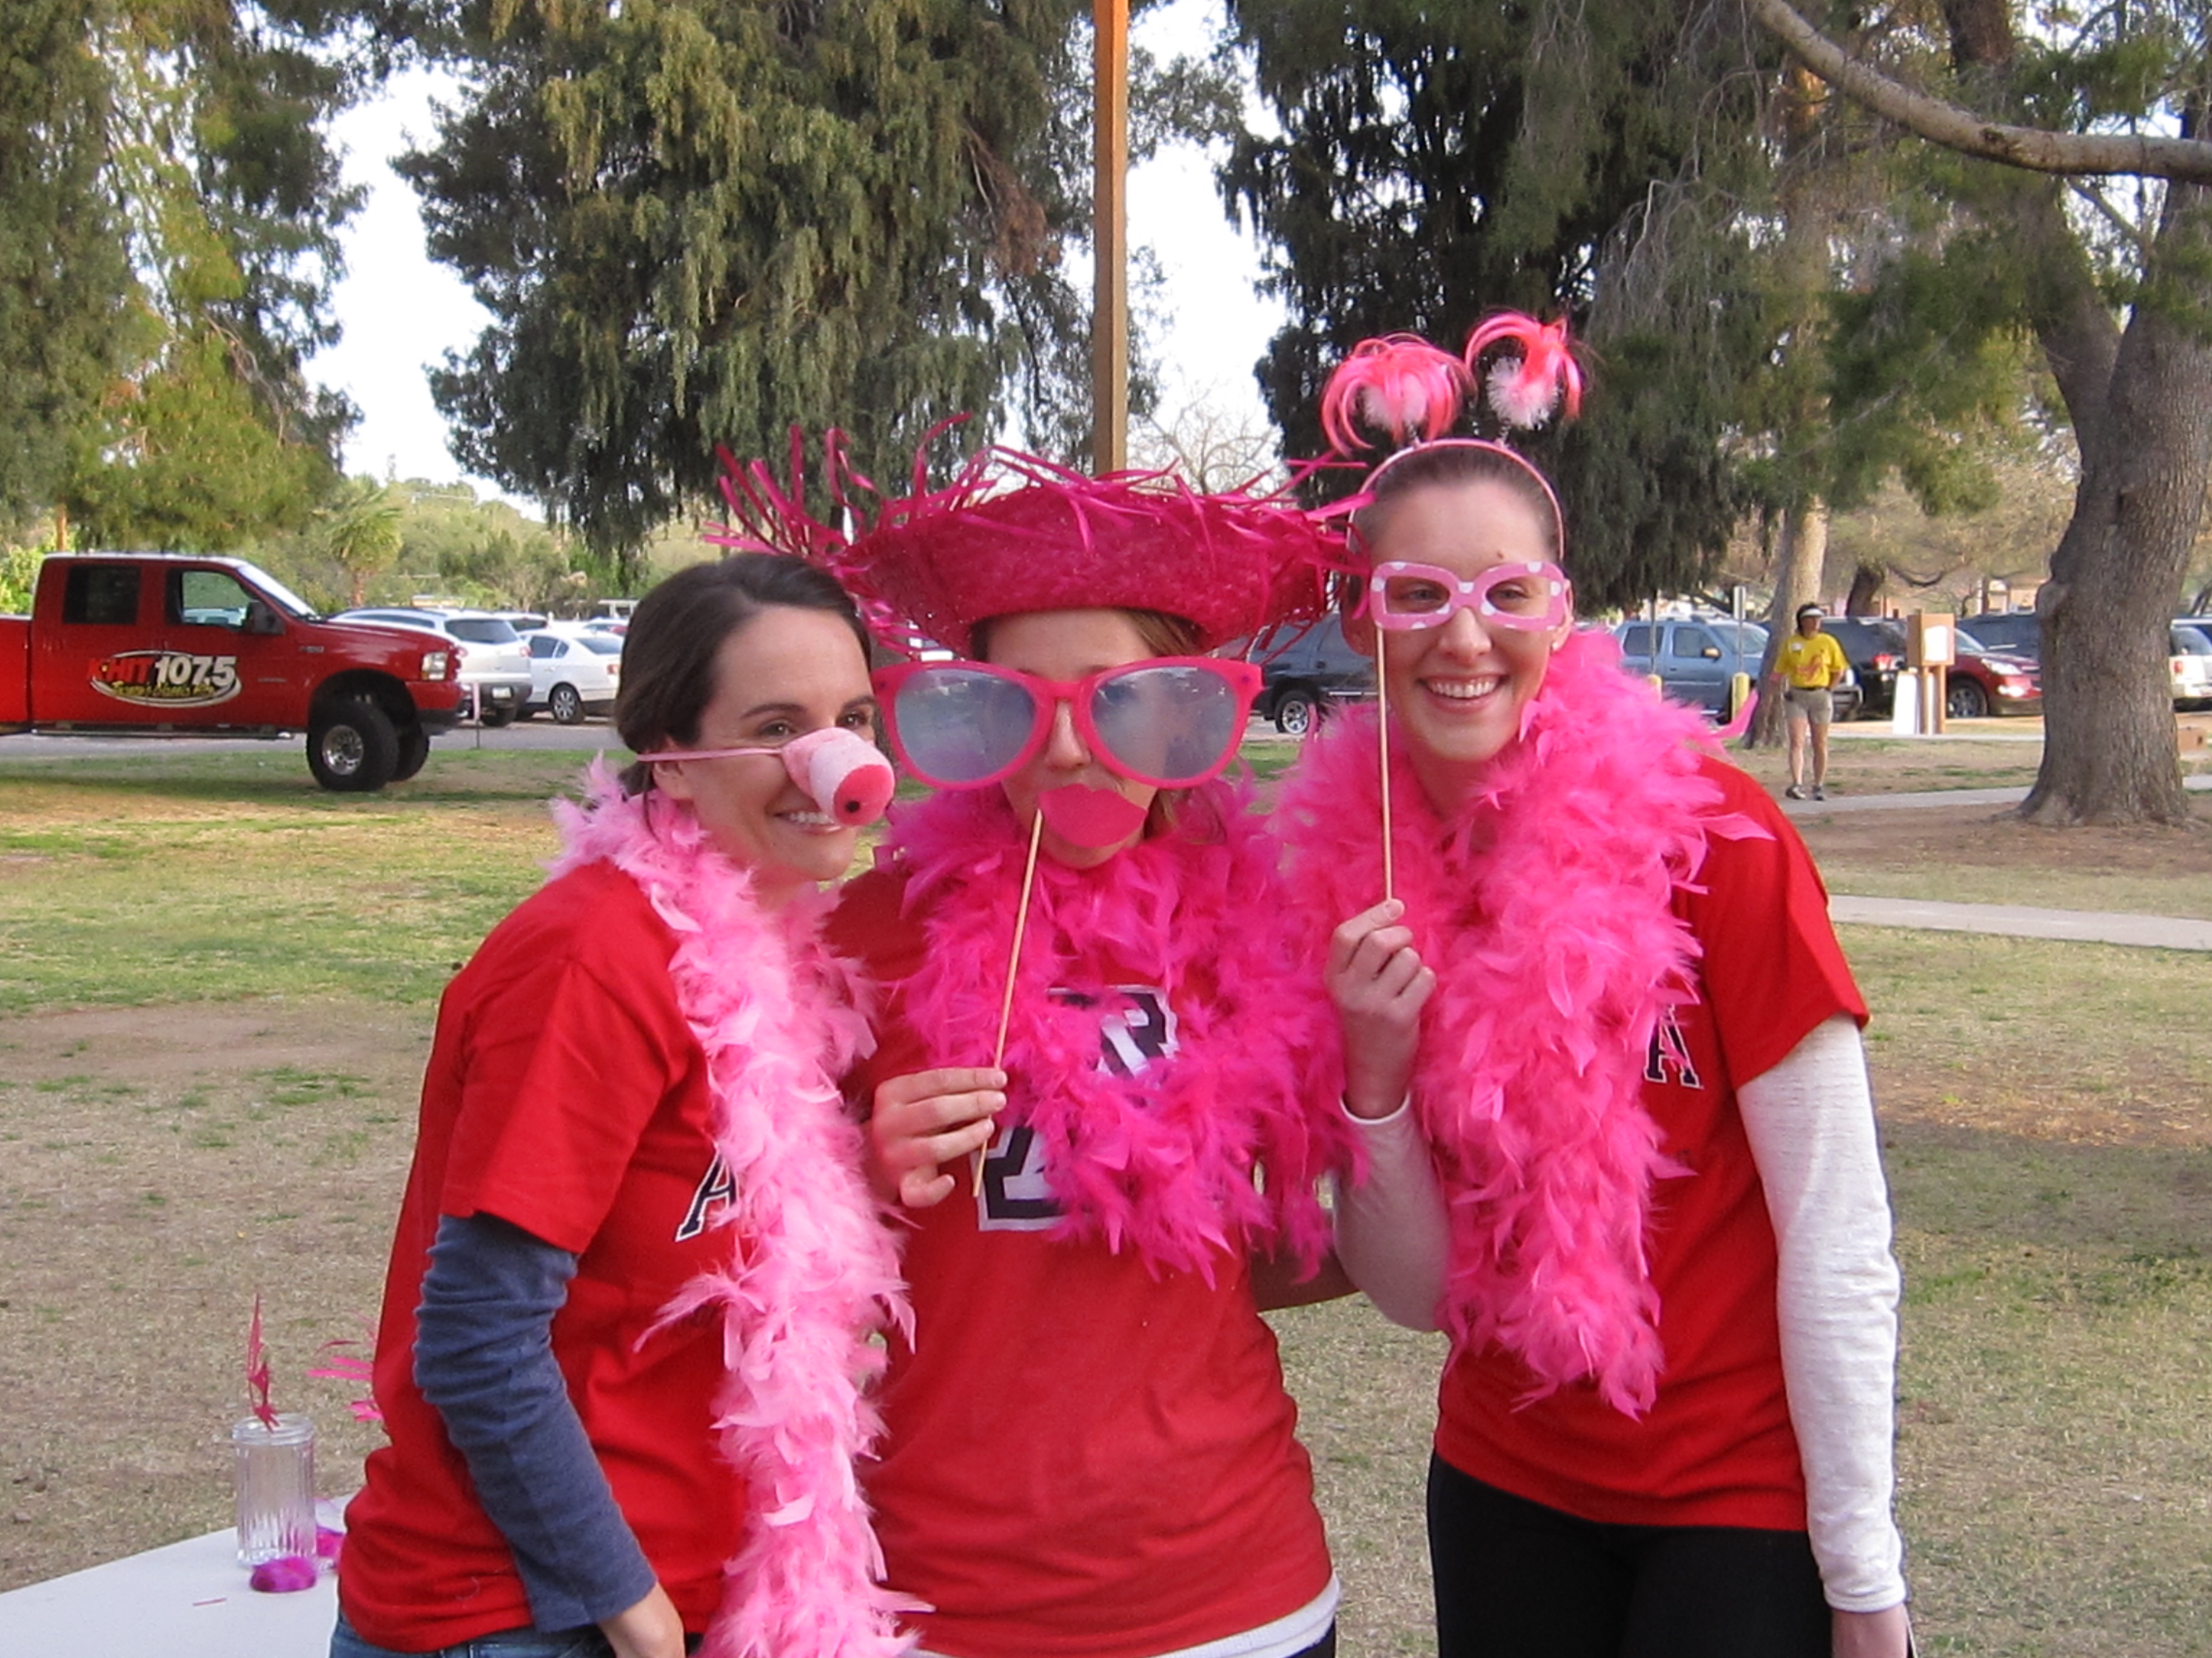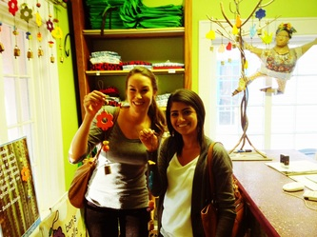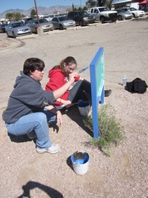

Stay tuned for

meeting times, philanthropy events &

socials this summer

Group Philanthropy Event: Beads of Courage Event

5:30-8:30 pm CON117

Monthly Meeting:

3:30pm CON 117

Incoming Class Q&A:

4:30pm CON 117

Social at No Anchovies on University

5:00 PM – 8:00 PM

[5/17]

[5/15]

[5/14]

June/July/August

Congratulations on this exciting new chapter in your life. MSO is the MEPN Student Organization. Our mission is to orient Master’s students to the profession of nursing through education, career opportunities and philanthropy while collaborating among students and faculty with an advisory council.

Career Opportunities: We hold a monthly meeting where an RN within the community comes to speak on behalf of his or her career. Our speakers hold positions within the nursing field we will not have the opportunity to be completely exposed to during clinical rotations or class time.

Philanthropy: Each month the philanthropy committee arranges a group philanthropy opportunity within the community along with multiple individual opportunities.

Student Advisory Council: One student per class acts as the student liaison between faculty and MEPN students

# Welcome MEPN 2013 Class!

May 1st , 2012

## Summer Schedule

#### Want to join?

#### Come to our next meeting May 15th at 3:30pm in CON 117

Establishing nurses through career opportunities, philanthropy & education

MSO News

Welcome MEPN 2013 Class

Please see the attached Constitution or refer to the [**MSO Website**](http://uamso.weebly.com/index.html)

**Transition Phase:**

* May, June and July’s MSO meetings will overlap between the 2012 and 2013 class.
* Any student in the Master’s Entry to the Profession of Nursing Program at The University of Arizona can be an active member and may hold office.
* Plan on 2-3 socials this summer.

**Recognition @ Graduation:**

* MSO members are adorned with a stole of designation and one member receives the MSO award.

**Elections:**

Elections for the Executive Board and Committee Directors will be held at the June 2012 meeting. The officers must be elected by a majority vote of the general MSO membership.

**Positions**:

Executive Board:

President, Vice President, Secretary, Treasurer

Committee Directors: Philanthropy Chairs(3), Career Opportunity Chairs(2), Student Advisory Council(SAC) Chairs

Chairs:

Homecoming (2), Transition, Social (2), Webmaster, Historian, Commencement

**Requirements:**

* Active membership will be granted to those students who attend 50% of the meetings throughout the duration of the program, one MEPN social event each semester, and 3-4 hours of philanthropy each semester with at least one throughout the program’s entirety being an MSO group philanthropy event.
* Responsibilities for officers are available in the attached Constitution.
* $13 fee is allocated for the MSO shirt. Orders will be taken at the June meeting. Graduation stole orders will be completed next summer.

Race for the Cure Photo Booth

Ben’s Bells

Cats in the Community

Questions?

### **How to Become a Member:**